UNHCR
King’s MUN - Tutorial Committee

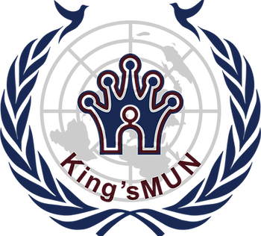
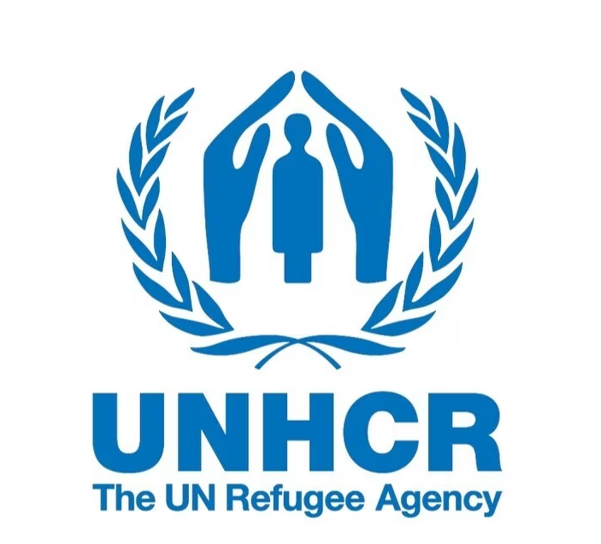
King’s MUN February 26, 2026

Table of Contents

- Welcome Letter ………………………………………………………………………...……..….. 3
- Purpose of Committee ……………………………………………………………………..….…. 4
- Topic I: Human trafficking and protection of women in vulnerable regions .............................. 4-6
- Topic II: Expanding employment and education opportunities for refugees in host countries ... 7-8
- Works Cited ………………………………………………………………………...………… 9-10

Dear King’sMUN 2026 delegates,

As this year’s Co-Secretary Generals of King’sMUN, we are truly honoured to welcome you to our 12th annual conference. The Secretariat has been working hard throughout this school year to deliver you an incredible, in-person conference with various unique committees, experienced chairs, and a fruitful day of debate.

Model United Nations, a reenactment of the function of the United Nations, is designed for students to come together to debate, discuss, and develop creative resolutions to various pressing issues that plague our current world. In most committees, students take on the positions of multiple countries, characters, or political figures to create solutions for real and fictional issues and crises. Our committees delve into historical events, future scenarios, and fictional topics.

In our personal experiences with MUN, we have developed many skillsets which will lead us throughout our lives, such as confidence in public speaking, leadership, collaboration,
and creative problem-solving. Furthermore, MUN promotes lifelong connections, as we meet delegates who share similar passions in committee sessions. We genuinely believe that your participation in MUN will guide you throughout your high school journey and beyond.

At King’sMUN, we provide a variety of committees to ensure that we have something of interest for everyone. From very current pressing issues (i.e. UNSC and the GA) and issues in sports (i.e. NFL) to fictional committees, yet applicable issues (i.e. Pokémon, Grammys, and Zootopia), issues set in our very own communities (i.e. Ontario Secondary and Post-Secondary Education and Government of Canada) and future-projected crises to promote critical thinking (i.e. Canada vs. U.S. and Artificial Intelligence). We strive to ensure that there is appeal for a variety of delegates, so that you can truly engage with MUN’s benefits in a way that resonates with you. Whether you have no experience or have attended many conferences, there is a place at King’sMUN for you!

Once again, we are thrilled to welcome all delegates, new or returning, to King’sMUN. We hope you will engage in fruitful debate and have a fantastic time at King’sMUN 2026.

Sincerely,
Eva Hanoudi and Ishan Ramchandani
Co-Secretary Generals
King’sMUN 2026

Purpose of Committee

The United Nations High Commissioner for Refugees, also known as the United Nations Refugee Agency, was created by the United Nations with the goal to protect refugees, internationally displaced persons (IDPs), stateless persons, and asylum-seekers. Currently, over 36.8 million people around the world depend on the UNHCR for protection, and the agency has worked with more than 100 different countries globally (“Who We Help”). The UN Refugee Agency works to protect and provide aid to those who are forced to flee their homes due to conflict and prosecution. The UNHCR provides both emergency aid and long term aid to those in need by providing long term solutions such as education and skill training. The UNHCR also works to help end statelessness by helping people gain a nationality. The goal of the UNHCR is to ensure that everyone who is fleeing war, violence, or persecution has the right to seek asylum and find refuge. Since the formation of the UNHCR in 1950, the UN Refugee Agency has helped millions of refugees and displaced persons and has received the Nobel Peace Prize twice (“Who We Help”).

Topic I: Human trafficking and protection of women in vulnerable regions
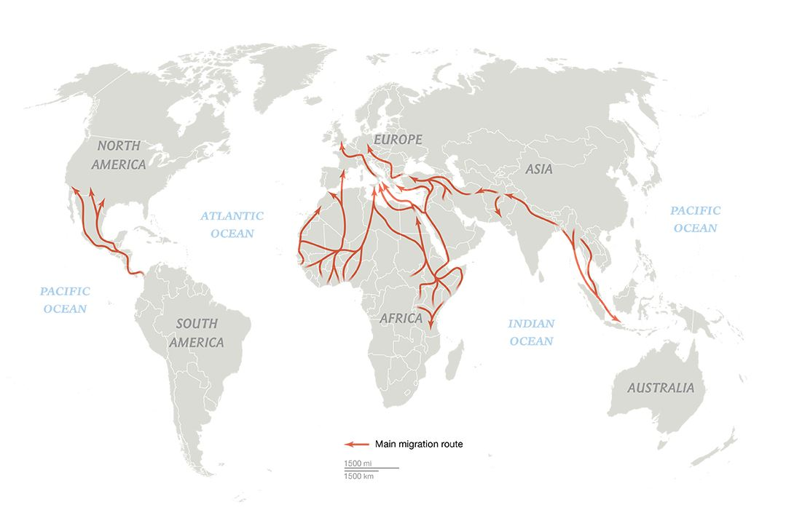
The United Nations created the United Nations High Commissioner for Refugees (UNHCR) in 1950 to provide protection and assistance to refugees, asylum-seekers, internally displaced persons (IDPs), and stateless people. Currently there are 117.3 million people worldwide that are forcibly displaced which opens up space for human trafficking to occur (UNHCR). The UNHCR currently works largely with countries like Venezuela, Syria, Myanmar, Afghanistan, Democratic Republic of Congo, South Sudan, and Ukraine to assist and provide services to IDPs and refugees in camps and in urban settings. Many countries such as Iran, Turkey, Colombia, Germany, Pakistan, Uganda, Ethiopia and Poland are taking in refugees from these countries (Concern Worldwide, 2025). Many people who are being trafficked are refugees seeking safety, however, in the course of their journeys migrants often lack access to safe water, and endure significant exposure to natural hazards and dangerous animals. Most human trafficking routes pass through Central America, North Africa, and the Mediterranean regions. Many migrants cross the Mediterranean sea which exposes them to many risks and possible death, it is considered the world's deadliest migration route for refugees and migrants. According to the United Nations Office on Drugs and Crime, “While men are the majority of those undertaking the sea journey, women appear to be disproportionately at risk of dying on this route” (United Nations Office on Drugs and Crime, 2021). While human trafficking affects all, refugee women experience a lot more violence during their refugee journey particularly in the Middle East and North Africa (MENA) region. Outside refugee camps, women who lack the protection of cross-border policies are vulnerable to trafficking networks, authority figures, and other perpetrators of gender based violence to harm refugee women without fear of repercussions. According to a research analysis of refugee women in the region of MENA, “as of 2019, 20% of all internally displaced or refugee women have experienced sexual violence…however, female refugees within the MENA region experience violence to an even higher degree” (Cole and Huang 2022). More than 60 million women and girls who are refugees or internally displaced face higher risk of trafficking and gender-based violence in regions affected by conflict or poverty (UN News). To protect women in these vulnerable regions and prevent human trafficking, the UNHCR provides safe spaces for women and survivors which includes legal aid, safe housing, and guidance to legal asylum rights. The UNHCR has also created a formal Guidelines on the Protection of Refugee Women, which creates specific protections against sexual and physical abuse, exploitation towards women (UNHCR). However, despite these efforts, many refugees live outside of these camps in urban areas where protections are limited. The UNHCR also struggles facing funding shortages which restricts the amount of support they can give.
Guiding Questions
- Why are refugee and internally displaced women immensely vulnerable to human trafficking during displacement, specifically in the Middle East and North Africa region?
- What limitations does the UNHCR face when trying to protect refugee women living outside formal camps in urban areas?
- What responsibilities do host countries for refugees have in preventing trafficking and protecting refugee women within their borders?
- How do funding shortages impact UNHCR’s ability to implement gender-specific protection programs, and what alternative funding could be explored?
- To what extent have the UNHCR current initiatives to help women, such as the women-friendly safe spaces and the Guidelines on the protection of Refugee Women, been effective in preventing trafficking and violence against refugee women?
- Further, what changes can be made to current UNHCR efforts to contribute to solving this problem?

Topic II: Expanding employment and education opportunities for refugees in host countries
One of the main goals of the UNHCR is to help refugees and internationally displaced people (IDPs) access employment so they can support themselves and their families, and to provide education to children and young people. In this way, the help being given would be sustainable and helps those in need long-term. The UNHCR works with host countries who are willing to take in refugees from other places, the biggest hosts being: Colombia (2.8 million), Germany (2.7 million), Türkiye (2.7 million), Islamic Republic of Iran (2.5 million), and Uganda (1.9 million). Approximately 83% of the world’s refugees live in countries with either still developing or the least developed economies, many of these host countries are dependent on international support to help with the cost of these refugee programs (UNHCR). It becomes a problem when funding becomes limited because it limits the effectiveness of the refugee programs. Another challenge often faced is the accessibility to gain ID-related requirements for those who are stateless or a refugee. A refugee who cannot legally open a bank account or access a mobile money wallet is severely limited with what they can do. The UNHCR notes that “ the lack of legal certainty, inconsistently applied regulations or sudden changes in regulatory expectations as regards identification can disrupt the delivery of humanitarian assistance.” Education access also remains a major barrier, according to UNHCR’s 2022 Education Report, stating that “Only 37% of refugees are enrolled in secondary school… and only 6% are enrolled in higher education.” Refugees face very limited opportunities with education because of the language differences and cost of learning. Some current efforts, however, include ones such as The Jordan Compact, which was established in February 2016. This deal granted Jordan billions of dollars in loans and preferential trade agreements with the European Union. In return, Jordan would give access to education and legal employment for its Syrian refugees. This compact has made great improvements to education and job access for Syrian refugees (Hagen-Zanker, 2018).
Guiding Questions
- What legal barriers prevent refugees from accessing employment in host countries, and how can the host governments address this problem without straining local labor markets?
- How can host countries expand access to secondary and higher education for refugee youth, considering the language, cost, and recognition of prior education are the barriers?
- What role can international organizations play in providing sustainable employment or educational opportunities for refugees?
- How can successful initiatives, such as the Jordan Compact, be adapted and applied to other host countries?
- How can UNHCR and host countries measure the effectiveness of employment and education programs to make sure that refugee self-reliance is genuinely improved?

Works Cited

“Who we Help.” UNHCR Canada, https://www.unhcr.ca/about-us/who-we-help/. Accessed
January 2 2026.

“What We Do.” UNHCR,
https://www.unhcr.org/what-we-do. Accessed 28 December 2025.

“Refugee Facts and Statistics.” UNHCR,
https://www.unrefugees.org/refugee-facts/statistics/#:~:text=More%20than%2018%20million%20people,69%25. Accessed 28 December 2025.

“Abused and Neglected.” UNODC, 2021,
https://www.unodc.org/documents/human-trafficking/2021/Aggravated_SOM_and_Gender.pdf. Accessed 28 December 2025.

Cole and Huang. “Violence Against Refugee Women in the MENA Region.” Ballard Brief, 2022,
https://ballardbrief.byu.edu/issue-briefs/violence-against-refugee-women-in-the-mena-region#:~:text=Summary+,women%20without%20fear%20of%20repercussions. Accessed 29 December 2025.

“Information Note on UNHCR’s Guidelines on the Protection of Refugee Women.” UNHCR,
https://www.unhcr.org/publications/information-note-unhcrs-guidelines-protection-refugee-women. Accessed 3 January 2026.

“Gender-Based Violence.” UNHCR,
https://www.unhcr.org/what-we-do/protect-human-rights/protection/gender-based-violence?_gl=1%2Aazdlb2%2A_gcl_au%2AMTc0NDk0ODAwNy4xNzY2NDI3NTA4%2A_ga%2AMTQ2MDYxNDIyLjE3NjY0Mjc1MDg.%2A_ga_X2YZPJ1XWR%2AczE3Njc1NjUwODAkbzQkZzAkdDE3Njc1NjUwODAkajYwJGwwJGgw%2A_rup_ga%2AMTQ2MDYxNDIyLjE3NjY0Mjc1MDg.%2A_rup_ga_EVDQTJ4LMY%2AczE3Njc1NjEwNTMkbzUkZzEkdDE3Njc1NjUwODAkajYwJGwwJGgw. Accessed 3 January 2026.

“Sexual Exploitation of Refugees in Uganda.” Wikipedia,
https://en.wikipedia.org/wiki/Sexual_exploitation_of_refugees_in_Uganda?utm_source=chatgpt.com. Accessed 3 January 2026.

“Which Countries Take in the Most Refugees?” Concern Worldwide, 24 July 2025,
https://www.concern.net/news/which-countries-take-in-the-most-refugees. Accessed 3 January 2026.

Chwastyk and Williams. “Maps.” IOM,
https://weblog.iom.int/worlds-congested-human-migration-routes-5-maps. Accessed 3 January 2026.

“Millions of Women and Girls Forced to Flee Face High Risk of Gender-Based Violence:
UNHCR.” UN News, 2024, https://news.un.org/en/story/2024/11/1157596. Accessed 3 January 2026.

Hagen-Zanker “The Jordan Compact: Lessons Learnt and Implications for Future Refugee
Compacts.” Overseas Development Institute, 2018, https://odi.org/en/publications/the-jordan-compact-lessons-learnt-and-implications-for-future-refugee-compacts/#:~:text=In%20February%202016%2C%20a%20new,improve%20the%20lives%20of%20refugees. Accessed 4 January 2026.

“Refugees’ Access to Jobs and Financial Services.” UNHCR, 2023,
https://www.unhcr.org/sites/default/files/2023-03/background-guide-challenge-3-refugees-access-to-jobs-and-financial-services.pdf. Accessed 4 January 2026.

“Refugee Data Finder.” UNHCR, 2025, https://www.unhcr.org/refugee-statistics. Accessed 4
January 2026.

