

Ontario Secondary and Post Secondary Institutions

Authored by: Ishan Ramchandani and Noah Robertson
Saturday, February 21, 2026

Table of Contents
I - Letter from Secretary Generals
II - IMPORTANT: Committee Disclaimer and Instruction
III - Topic 1: University admissions and census quotas: balancing equity, merit, and representation
III.A - Context and Overview
III.B - Recent Developments
III.C - Major Players and Case Studies
III.D - Guiding Questions
IV - Topic 2: Inequalities and barriers to educational experiences
IV.A - Context and Overview
IV.B - Recent Developments
IV.C - Major Players and Case Studies
IV.D - Guiding Questions
V - Contact Information
VI - Resources

I - Letter from Secretary Generals
Dear King’sMUN 2026 delegates,

As this year’s Co-Secretary Generals of King’sMUN, we are truly honoured to welcome you to our 12th annual conference. The Secretariat has been working hard throughout this school year to deliver you an incredible, in-person conference with various unique committees, experienced chairs, and a fruitful day of debate.

Model United Nations, a reenactment of the function of the United Nations, is designed for students to come together to debate, discuss, and develop creative resolutions to various pressing issues that plague our current world. In most committees, students take on the positions of multiple countries, characters, or political figures to create solutions for real and fictional issues and crises. Our committees delve into historical events, future scenarios, and fictional topics.

In our personal experiences with MUN, we have developed many skillsets which will lead us throughout our lives, such as confidence in public speaking, leadership, collaboration,
and creative problem-solving. Furthermore, MUN promotes lifelong connections, as we meet delegates who share similar passions in committee sessions. We genuinely believe that your participation in MUN will guide you throughout your high school journey and beyond.

At King’sMUN, we provide a variety of committees to ensure that we have something of interest for everyone. From very current pressing issues (i.e. UNSC and the GA) and issues in sports (i.e. NFL) to fictional committees, yet applicable issues (i.e. Pokémon, Grammys, and Zootopia), issues set in our very own communities (i.e. Ontario Secondary and Post-Secondary Education and Government of Canada) and future-projected crises to promote critical thinking (i.e. Canada vs. U.S. and Artificial Intelligence). We strive to ensure that there is appeal for a variety of delegates, so that you can truly engage with MUN’s benefits in a way that resonates with you. Whether you have no experience or have attended many conferences, there is a place at King’sMUN for you!

Once again, we are thrilled to welcome all delegates, new or returning, to King’sMUN. We hope you will engage in fruitful debate and have a fantastic time at King’sMUN 2026.

Sincerely,
Eva Hanoudi and Ishan Ramchandani
Co-Secretary Generals
King’sMUN 2026

II - Committee Disclaimer and Instruction
Disclaimer:
The nature of this committee and its topics are highly sensitive and applicable to environments proximate to our delegates, Chairs and facilitators. In order to ensure respect, dignity and fairness in our debate, it’s important to recognize the closeness of this topic to our daily lives. This also means, more than usually, these topics hold extreme weight and can much easier attack an individual’s personal sentiments and experiences.
Each educational style has unique value systems which we aim to unpack perspectives upon. We’ve discussed a few key tips we require all delegates to review, understand and accept prior to entering debate, to ensure we do not raise any concerns during our debate.

- Maintain your position and stance.
Do not speak from personal experiences, or from a first-person viewpoint. Recall that this is MUN, a chance for you to immerse within an external perspective. The more you bring your own experiences in, the more difficult it will be to maintain respect and order.
- Use Respectful Language.
Recognize that the committee will house individuals who are closely embodying the positions of some delegate assignments, and that everything you say to/as them can hold extra weight. Be respectful, always inquiring before assuming.

- Employ statistics and data to support your claims.
If you are making accusations or comments without support, it can appear to be personally motivated and offensive. Ensure your theories are rooted in fact and, therefore, that you are adhering well to your position. Presented data can be fact checked by other delegates.
- Remember that the purpose of this debate.
The goal of this debate isn’t to bash one system, advocate, or school board. It’s, truly, to understand where each unique perspective and what their ideologies are which causes them to implement/defend their systems.
- Consider OUR and YOUR administration’s sentiments during debate.
As a private Christian organization facilitating this committee, it should tell you how much we value the diversity of perspectives on this issue. To that same token, be respectful to the facilitators of this conference (our school, your schools) by understanding perspectives, not destroying them. We can only have such a diverse and good debate because of our present educational systems.
- Detach from personal experiences for the purpose of the debate.
Please note that since the nature of this committee is such, awards will also be heavily weighted based on the above criteria. Ensure you have reviewed them ahead of time, although we will proceed through them as a committee before our first session. Feel free to ask questions now, or at this time.

Position Papers
A Position Paper must be submitted in order to be considered for an award. While Position Papers shouldn’t generally contain all of your research, please note that they must contain most of the necessary information to provide an overarching understanding of the topic (Paragraph 1), how it affects your position (Paragraph 2), and some plausible resolutions (Paragraph 3). Feel free to deviate creatively from this general template (format is not assessed, content and flow are). Use of AI in position papers may lead to ineligibility for awards.
When submitting a position paper, please print out 2 copies so that you can keep one during debate and the other can be physically handed in to the chair at the start of debate. We will, as per our conference policy, not accept digital submissions, and minimize (or not allow) referral to online resources during regular debate time (with the exception of unmoderated caucuses).

III - Topic 1

University admissions and census quotas: balancing equity, merit, and representation

III.A - Context and Overview
Educational admissions systems in Canada and across the world employ the use of quotas, often cited as a means to ensure fair representation of diverse populations within institutions. A university quota refers to reserving a specific percentage of admissions to the institution for “categories” of applicants. Often, quotas emphasize minority categories. These categories include race, gender, sexuality, financial stability and ethnicity.

Quotas were initially introduced to do the contrary of what they strive to achieve today. “Jewish Quotas” refers to the introduction of quotas in North American post-secondary educational institutions. These were quotas which limited the number of Jewish students universities like McGill and the University of Toronto could host (Wikipedia). McGill’s quota was the longest-running in North America, lasting 40 years between 1920 and 1960. Much of these ideologies were in tandem with German-fueled anti-semitism which was becoming popular. Quotas were a tool used to advance discrimination. Today, they’re designed to ensure ‘minorities’ are equally represented to other populations.

Quotas particularly apply to institutions with admissions processes, namely, universities. Its effects on Secondary Schools across Ontario are quite limited - of course, that is, only if the regular public high school system is being considered. Quotas are innate to certain religious high schools or private high schools. The argument of choice defends these implementations, suggesting that a student who is of merit and still rejected from admission has other options of equal education. Another interesting debate arises as to if “equal” education actually exists, which will be explored in the second topic more seriously.

A United States national study in 2023 discovered that private, selective universities and programs utilize racial quotas more heavily. An example of certain criteria private universities use to evaluate applicants is attached below. Note that there are 19 academic and non-academic factors; each university places a different importance level on each factor, meaning admission criteria varies from school to school. This study in the United States quoted that 26% of universities testified that they do not consider race or ethnicity whatsoever in their application decision (Pew Research Center). Many specialized programs, for example UofT’s Faculty of Medicine, have made an explicit effort to increase the quota for Jewish people considering their oppressive history (UofT Faculty of Medicine). Similarly, their Rotman School of Management (Business) released an article discussing how 5% of the Fortune 500 CEOs in 2016 were women. This was the backbone for justifying their gender quotas in their admission process (University of Toronto, Rotman School of Management).

It must be recognized that within Ontario, there are institutions which do implement application processes for admissions, while some are rather automatic. This, thereby, increases the potential for difficulty and proneness to quotas – which further research will discuss as both, equitable and sometimes challenging. The debate as to whether quotas are more just than discriminatory present itself prominently in society today. The first argument is that quotas allow under-represented, oppressed minorities to be more equally considered in access to education. However, the opposing argument is that quotas limit justice by over-valuing certain “categories” of applicants over others, giving them an unfair chance in acceptance, based on non-merit factors.

Another aspect is scholarships and financial aid. OSAP (Ontario Student Assistance Program) is a financial aid program which provides grants and student loans to eligible students, who apply. While quotas focus on providing a “seat” in universities or educational institutions, they often overlook the fact that in order to truly secure this spot and administer this education, compensation is required. This effectively defeats the purpose of quotas if an applicant is financially insolvent, because the seat would be revoked and given to another student, who can provide compensation. This is why many institutions offer scholarships and financial aid packages, based on a combination of merit and financial need. Many non-financially needy students have spoken up, frustrated with the lack of representation they have in scholarship receivals, despite extraordinary merits. In 2024, 377, 860 Ontario students applied for and received OSAP loans. Loans differ from financial aid in that loans need to be repaid later on in life.
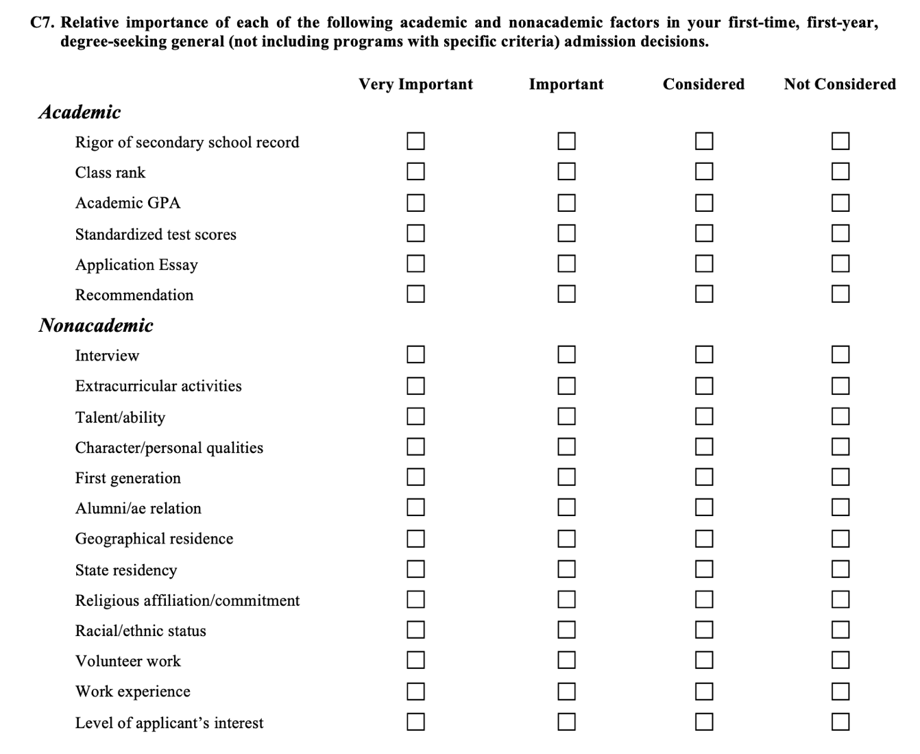

III. B - Recent Developments
In 2024, the University of Toronto’s Faculty of Medicine published an article (which many quoted as a formal apology). This paper discussed the extent of discrimination which the University of Toronto, among many others, employed in past years and how limiting their programs were for certain populations, like the Jewish community. It also discussed “retaliatory” quotas, which seemingly reverse the effects of the year before.

An American survey conducted this past year released results saying that most Americans “disapprove of institutions considering race” in their admissions process (Pew Research Center).

III. C - Major Players + Case Studies
The University of Toronto’s 2024 National Scholarship, enables 12 ‘Scholars’ to study at their University, virtually free of cost. The scholarship considers a combination of original and creative thought, extracurricular involvement, financial need, and academic strength. Many winners said that they would be unable to consider studying at UofT without the financial support of the scholarship (University of Toronto National Scholarship). There is tremendous backlash surrounding majority populations, who feel that they are at a disadvantage when it comes to admissions, and financial aid; opportunities essential to succeed in education.

III.D - Guiding Questions
- Consider what truly constitutes a minority?
- What makes a candidate truly worthy of extra seats in a university (especially in comparison to other students)?
- What is merit? Is it determined by one’s innate capacity or one’s educational opportunities/mentorship/”category”
- Is it fair that certain students are considered more favourably because of factors they physically cannot control? Why?
- Should quotas be removed? If not, is there a better alternative?
- Who should hold the power in making admission decisions? How do we ensure their decisions are just?
- IMPORTANT: Are retaliatory quotas (quotas which over-allow a previously discriminated against population to have seats) justified? Do they employ discrimination in trying to fight discrimination?

IV - Topic 2
Inequalities and barriers to educational experiences

IV.A - Context and Overview
Ontario educates roughly 2 million students across its 72 publicly funded school boards (2021-22)(Financial Accountability Office of Ontario). This large system is vastly diverse: featuring a multitude of both English and French schools spread across urban and rural areas. Ontario’s education board disperses funds to these schools primarily based on enrollment resulting in a wide variety of experiences per community. At the national level, Ontario holds high academic outcomes, yet issues in the system persist. At the basic level; income, location and educational disabilities continue to influence ability to access quality programs. For example, wealthier urban school boards are able to offer more resources and activities to their students, widening the gap to areas that may not be able to offer the same resources.

Students from lower-income families often face many issues regarding education in Ontario. One report observed that Covid-19 pandemic “exacerbated education inequalities between lower and higher-income students” (Canadian Center for Policy Alternatives). Schools in more expensive regions are far more likely to offer a large range of clubs, sports and additional programs to their students than those in poorer areas. For example, high-income schools are much more likely to offer advanced courses such as IB or expensive clubs such as robotics. In contrast, lower-income schools often report an absence in “specialized activities” and relied on outside assistance to continue running existing programs. Differences in funding amplify this gap: during 2022-23, only 70% of secondary schools reportedly held fundraising campaigns (down from 88% before the pandemic)(PeopleForEducation). Additionally, high-income schools raised on average three times more than low-income schools. Such shortfalls often led to less money able to be devoted to sports, clubs and activities.

Ontario has over 350 000 K-12 students with special education requirements. Yet obstacles to provide for them remain firm, the Ontario Human Rights Commission notes that “inadequate funding” is one primary cause of issues regarding inadequate services at the elementary and secondary school level. Many schools often face long wait times for assessments or resources to assist students who need them. Roughly half of Ontario schools report shortages for specialized staff. Lower-income and remote schools can often face worse shortages; only 67% of elementary schools in low-income areas have access to psychologists versus 84% in high income areas (PeopleForEducation). Advocacy groups and public institutions report that if these patterns continue, many individuals who require these supports will fall behind.

Where a student lives in Ontario also can affect their school experience and the resources they have access to. Rural and northern communities often have fewer courses, fewer specialized teachers, and less access to extracurricular activities. Many rural schools operate on a lower budget due to low enrollment leading to less staff and older facilities. Recruiting staff members is also becoming increasingly harder as more and more teachers leave due to large support gaps.

IV.B - Recent Developments
In the past five years, multiple developments have changed these barriers. The COVID-19 Pandemic resulted in mass school closures and forced online learning. These changes hit students facing disadvantages the hardest; remote and low-income schools were closed for prolonged periods of time, gaps in education inequalities were deepened and students faced severe learning losses–shown through dwindling EQAO results. The Ontario government has made some changes to assist the education system including increasing the budget from $26-29 billion per year which was criticized for only matching enrollment growth. Furthermore, skepticism from advocacy groups about the budget per student has grown as some reports suggest the average budget per student has declined.

IV.C - Major Players
Ontario Ministry of Education: Distributes funds and curriculum.
Ontario Human Rights Commission: Ensures that the Ontario education system is fair to everyone and maintains human rights.
People For Education: An independent non-profit that surveys schools and produces annual reports on educational access by income and region.

IV.D - Guiding Questions
- How can transportation and staffing shortages in remote communities be addressed so that rural and Northern students have access to more educational opportunities?
- What initiatives should Ontario consider to help students who have fallen behind to catch up?
- How should Ontario change how they fund education so that those in low-income areas have more comparable opportunities to those in wealthier areas?

V - Contact Information
If you are to confront any inquiries, hesitations or general questions throughout your preparation for debate, please, do reach out. We are incredibly passionate about this topic and have several experiences which have enabled us to be moderating this committee. Inquiries will be fielded as soon as possible (likely within 24-48 hours) by either Ishan or Noah.

To reach us:
Ishan Ramchandani (Chair): ishanramchandani@icloud.com
Noah Robertson (Co-Chair): noahmrobertson@icloud.com

We look forward to getting to know you all on the day of KingsMUN, Saturday, February 21st!
Thank you for your interest in this committee.

VI - Resources
https://en.wikipedia.org/wiki/List_of_school_districts_in_Ontario
https://peopleforeducation.ca/report/inequities-persist-extracurriculars-clubs-activities-and-fundraising-in-ontarios-publicly-funded-schools/#:~:text=Survey%20responses%20revealed%20that%20the,the%20exception%20of%20breakfast%2Fnutrition%20programs
https://www3.ohrc.on.ca/en/right-read-inquiry-report/13-systemic-issues https://fao-on.org/en/report/fa2207schoolboards/#:~:text=%2A%20In%202021,school%20boards%20and%2034%2C588%20students
https://www.policyalternatives.ca/wp-content/uploads/attachments/Catching%20Up%20Together.pdf#:~:text=The%20COVID,students%20will%20be%20left%20behind

