General Committee: European Union

KingsMUN 2026

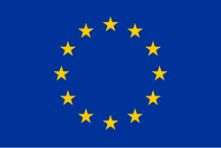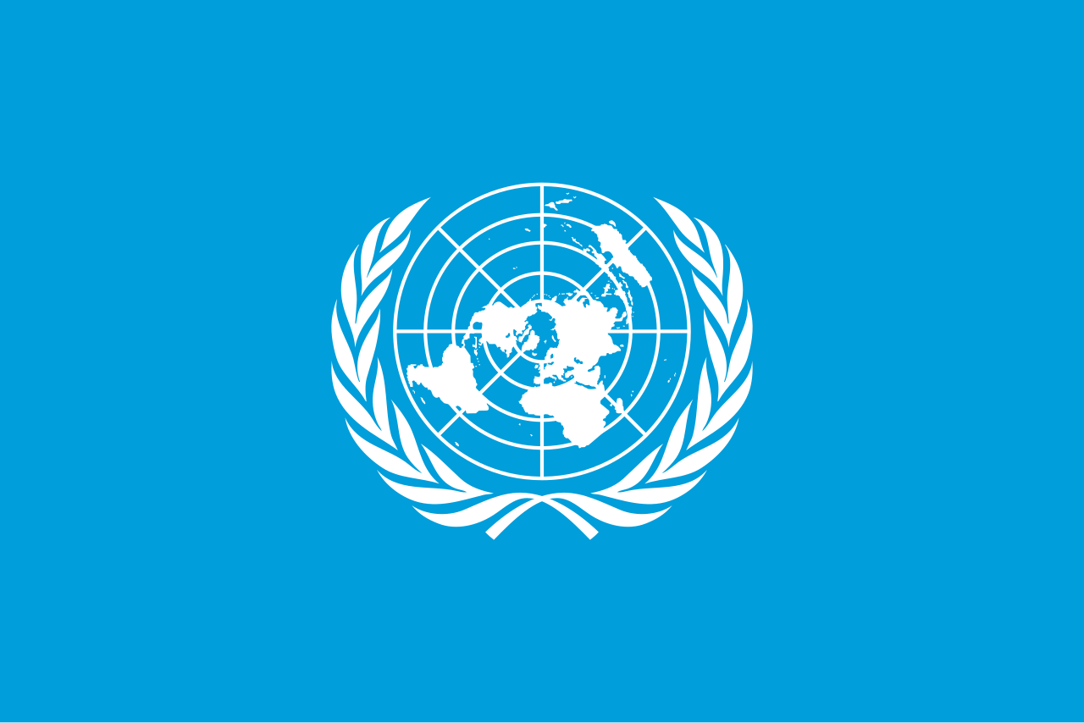

Chair: Marc Ghaly

Co-chair: Nelson Perez-Gutierrez
Dear King’sMUN 2026 delegates,

As this year’s Co-Secretary Generals of King’sMUN, we are truly honoured to welcome you to our 12th annual conference. The Secretariat has been working hard throughout this school year to deliver you an incredible, in-person conference with various unique committees, experienced chairs, and a fruitful day of debate.

Model United Nations, a reenactment of the function of the United Nations, is designed for students to come together to debate, discuss, and develop creative resolutions to various pressing issues that plague our current world. In most committees, students take on the positions of multiple countries, characters, or political figures to create solutions for real and fictional issues and crises. Our committees delve into historical events, future scenarios, and fictional topics.

In our personal experiences with MUN, we have developed many skillsets which will lead us throughout our lives, such as confidence in public speaking, leadership, collaboration,
and creative problem-solving. Furthermore, MUN promotes lifelong connections, as we meet delegates who share similar passions in committee sessions. We genuinely believe that your participation in MUN will guide you throughout your high school journey and beyond.

At King’sMUN, we provide a variety of committees to ensure that we have something of interest for everyone. From very current pressing issues (i.e. UNSC and the GA) and issues in sports (i.e. NFL) to fictional committees, yet applicable issues (i.e. Pokémon, Grammys, and Zootopia), issues set in our very own communities (i.e. Ontario Secondary and Post-Secondary Education and Government of Canada) and future-projected crises to promote critical thinking (i.e. Canada vs. U.S. and Artificial Intelligence). We strive to ensure that there is appeal for a variety of delegates, so that you can truly engage with MUN’s benefits in a way that resonates with you. Whether you have no experience or have attended many conferences, there is a place at King’sMUN for you!

Once again, we are thrilled to welcome all delegates, new or returning, to King’sMUN. We hope you will engage in fruitful debate and have a fantastic time at King’sMUN 2026.

Sincerely,
Eva Hanoudi and Ishan Ramchandani
Co-Secretary Generals
King’sMUN 2026

Table of Contents
Topic 1. Cross-border drone surveillance and airspace violations 4
1.1 Introduction 4
1.2 Historical Background 4
1.3 Current Situation 5
1.4 Key Issues To Focus On 7
1.5 Questions To Consider 8
Topic 2. Establishing unified standards for travel and protection of migrants 8
2.1 Introduction 8
2.2 Historical Background 8
2.3 Current Situation 9
2.4 Key Issues To Focus On 10
2.5 Questions to Consider 10
Bibliography 12

Topic 1. Cross-border drone surveillance and airspace violations

1.1 Introduction
Under EU Regulation 2019/947, cross-border operations refer to drone flights taking place partially or entirely in the airspace of a Member State other than where the drone operator is registered. These operations fall under Article 13 of the Implementing Regulation and require coordination with the National Aviation Authority, NAA, of the destination country (AirHub). Cross-border, in its simplest form, refers to the movement of goods, services, people, or data across international borders. This concept is a cornerstone of global trade and involves interactions between entities in different countries.
A drone is an aerial vehicle, also known as an unmanned aircraft vehicle or UAV, designed to be used without a human pilot onboard (JOUAV). Drones can be remotely controlled, but some are capable of flying fully autonomously. Surveillance drones can be equipped with sophisticated imaging technology that provides the ability to obtain detailed photographs of terrain, people, homes, and even small objects. Drones regularly carry high-resolution cameras, infrared cameras, heat sensors, GPS, sensors that detect movement, and automated license plate readers. These cameras may include facial recognition technology that would make it possible to remotely identify individuals from a distance without their knowledge (EPIC).
In a number of zones of conflict, for example, between Russia and Ukraine, cross- border drone surveillance and airspace violations are a growing activity (Postnord), involving state-sponsored probing, like Russian drones flying into NATO countries airspace. Violations include flying too high (over 120 m), nighttime flights, and entering restricted zones, posing risks to national security and aviation safety.

1.2 Historical Background
The history of cross-border drone surveillance and airspace violations involves two distinct but overlapping areas: state-sponsored military or intelligence activities and non-state (e.g., criminal) uses for smuggling.
The use of drones for military and intelligence purposes across borders dates back at least to the early 2000s, with notable examples including U.S. drone strikes and surveillance in the Middle East and South Asia. The first known U.S. drone strike occurred in Yemen in 2002. Use became more frequent after 2008, particularly in Pakistan, where the number of strikes peaked in 2010. These operations generated significant international debate regarding sovereignty and the ambiguity of international law concerning drone warfare.
Beginning of year 2013, the Washington Post newspaper (Lynch) reported that the United Nations wanted to use drones for peacekeeping missions. In the same year, the international journal Stability reported that drones can help the United Nations closely monitor potential spoilers before using force, to monitor and record incidents where peacekeepers are using force to protect civilians, and to save all information thus gathered for later scrutiny and to share with the wider public for accountability purposes.

1.3 Current Situation
Since the Russian full-scale invasion of Ukraine, that began on February 24, 2022, the airspaces of non-combatant neighboring countries, NATO members and endorsing Ukraine, have been violated on several occasions by drones sent by Russia and Belarus, on one side, but also by Ukraine. The violations mostly targeted Romania and Poland, key NATO members having the longest borders with Ukraine, but also Moldova and the Baltic states.
Relevant statistics towards this topic are contained within the sample list below. The sample list has examples of such violations with date, countries involved and some further details (Wikipedia).
Table 1. Sample list of airspace drone violations linked to the Russo-Ukrainian war
Date | Affected country | Committed by | Details of violation
2022-03-10 | Croatia  Hungary  Romania | Undisclosed | A drone crashed in Zagreb, capital of Croatia, after traveling through Croatian, Hungarian and Romanian airspace.
2022-03-14 | Romania | Russia | A drone crashed in Romania
2022-04-29 | Sweden | Russia | A drone violated airspace for less than 1 minute.
2022-12-16 | Poland | Russia | A drone travelled through Belarusian airspace into Poland before crashing.
2023-09-04 | Romania | Russia | A drone crashed on Romania.
2023-09-30 | Romania | Russia | A drone violated Romanian airspace.
2023-12-14 | Romania | Russia | A drone crashed in Romania.
2024-07-25 | Romania | Russia | Three drones crashed in Romania.
2024-09-07 | Latvia | Russia | A drone crashed in Latvia after flying through Belarus.
2024-09-08 | Romania | Unknown | A drone crashed in Romania.
2024-09-27 | Romania | Unknown | A drone briefly violated the Romania airspace.
2024-10-17 | Romania | Unknown | A drone briefly violated the Romania airspace along 14 km before crashing on it.
2025-01-17 | Romania | Russia | Several drones violated the Romania airspace, before crashing on its territory.
2025-08-20 | Poland | Russia | A drone crashed and exploded in Poland, in a village 100 km inside the border with Russia. damaging some buildings in a village.
2025-08-25 | Estonia  Latvia | Ukraine | A Ukrainian drone veered off course due to Russia radio jamming violated Latvian airspace and traveled onward into Estonia, where it crashed and exploded.
2025-09-04 | Poland | Russia | Two drones violated Polish airspace until they left.
2025-09-08 | Poland | Russia | A drone crashed in Poland, near the border with Belarus.
2025-09-09 | Poland | Russia | At least 21 drones violated Polish airspace. Up to 4 were shot down, and one crashed more than 200 km from the border with Russia.
2025-09-13 | Romania | Russia | Two drones violated Polish airspace until it crossed into Ukraine. It was not shot down to avoid collateral damage.
2025-09-22 | Denmark | Suspected: Russia | Unidentified drones violated Denmark’s airspace near Copenhagen Airport
2025-10-17 | Estonia | Unknown | Two unidentified drones overflew a US Army Base in Southern Estonia; one of them was shot down.
2025-11-11 | Romania | Russia | A drone violated Romanian airspace and crashed on Romania after midnight.
2025-11-17 | Romania | Russia | A drone hit a Turkish liquid natural gas tanker at the port of Izmail, on the Danube, setting the ship on fire. Two Romanian villages on the river had to be evacuated as a security measure.
2025-11-19 | Romania  Moldova | Russia | A drone violated Romanian airspace, penetrated 8 km and returned to Ukrainian airspace again, and violated Moldovan airspace, returning back to Romanian airspace, and disappeared from the radar screen.
2025-11-22 | Netherlands | Unknown | Several drones overflew Volkel Air Base, home of Royal Dutch Air Force and USAF squadrons. The airport of Eindhoven was shut down for several hours. Dutch military on the ground opened fire, but no wreckage was found.
2025-11-25 | Moldova | Russia | A drone crashed on the roof of a house in a Moldovan village, 20 km from the Ukrainian border. The drone did not explode, and no people were injured. Other six drones violated Moldovan airspace in that morning.
2025-11-25 | Romania | Russia | Two drones were detected over Romania. One returned to Ukrainian airspace, and the other crashed after four hours in Romanian airspace.
2025-12-04 | France | Unknown | The French naval base at l’Ile Longue, Brittany, home of nuclear submarines, was overflown by five unidentified drones. The drones were intercepted by personnel at the base.
2025-12-15 | Turkey | Russia | A drone was shot down by a Turkish fighter plane over the Black Sea, after entering Turkish airspace. Two other drones were found crashed on 19 and 20 December in Turkish territory.

Two current challenges regarding this topic are:
- Can large countries freely violate smaller countries' airspace with drones without expecting any retaliation?
- What can the United Nations do to avoid such violations, and to intervene to condemn the violations already made, and take the necessary retaliation measures at the Security Council.
Current major powers involved in this topic are The Russian Federation, and Belarus, both former members of the extinct Union of Soviet Socialist Republics, USSR. The first is a nuclear superpower, with one of the biggest and better equipped Armed Forces in the world.

1.4 Key Issues To Focus On
- National security and illicit activities, as smuggling and potential attacks;
- Airspace safety, and possible operational disruption of air traffic;
- Legal & regulatory challenges, and enforcement difficulties;
- Privacy concerns and related data collection;
- Counter-drone technology limitations

1.5 Questions To Consider
- What are the ethical implications of states using drones for persistent surveillance near borders?
- How do drones normalize mass surveillance?
- Should consumer drones operating near borders face stricter regulations?
- How do drones challenge traditional notions of border control and national security?

Topic 2. Establishing unified standards for travel and protection of migrants

2.1 Introduction
This theme is crucial for managing global mobility, balancing national interests with humanitarian obligations, and ensuring safe, orderly migration. Cooperation between countries of origin, transit, and destination is required to uphold human rights and build efficient, just systems.
Existing legal instruments provide a comprehensive legal framework for the governance of international migration. Well-defined rules address the treatment of a range of migrants including, among others: migrant women, men, children, refugees, stateless persons, migrant workers, and migrant victims of trafficking (OHCHR).

2.2 Historical Background
The unprecedented arrival of almost two million people on European territory between 2015 and 2016 exposed the vulnerabilities of the EU’s Common European Asylum System, CEAS. Dating back to the 1990s the CEAS aims to homogenize the policies and procedures for the reception of asylum seekers or subsidiary protection of Member States while ensuring respect for human rights, based on the full application of the Geneva Convention.
In 2020, The European Commission announced a comprehensive reform affecting all CEAS instruments, aiming to implement a new system capable of proving effective management at EU level, while circumventing criticism from left-wing parties, NGO and civil society for the recurrent humanitarian crises in the Mediterranean Sea. However, the New Pact on Migration and Asylum continues to raise discrepancies between Member States, highlighting the latent divisions between blocs within the EU, as well as the inability to establish a credible mechanism of inter-European solidarity (Omeldo Alberca, Fonts Picas and El-Khatib).

2.3 Current Situation
The EU and its Member States are intensifying efforts to establish an effective, humanitarian and safe European migration policy. The European Council plays an important role in this effort by setting the strategic priorities. Based on these priorities, the Council of the EU establishes lines of action and provides the mandates for negotiations with non-EU countries. It also adopts legislation and defines specific programs. Over the past few years, the Council and European Council have built up a strong response to migratory pressure.
Asylum seekers should be treated uniformly across Europe; the EU is working towards this. The new rules, or migration and asylum pact, will make the European asylum system more effective and will increase the solidarity between Member States by enabling them to lighten the load on those Member States where most migrants arrive. Besides, the EU has adopted various rules to manage legal migration flows, process asylum requests and return irregular migrants (European Council).
Some facts and figures on irregular arrivals are given in Table 2 below (data up to November 2025). Western route refers to Western Mediterranean and Western African routes.
Table 2.Irregular arrivals to the EU from years 2015-2025
Year | Route
Year | Western | Eastern | Central
2015 | 7 004 | 885 386 | 153 946
2016 | 9 990 | 182 277 | 181 376
2017 | 23 063 | 42 319 | 118 962
2018 | 57 034 | 56 561 | 23 485
2019 | 23 967 | 83 333 | 14 003
2020 | 41 861 | 19 681 | 35 628
2021 | 41 945 | 20 567 | 67 724
2022 | 31 219 | 43 906 | 105 561
2023 | 56 852 | 60 177 | 158 020
2024 | 70 664 | 70 295 | 66 855
2025 | 34 251 | 45 868 | 62 934

Two current challenges regarding this topic are:
- Can the countries of the EU restrict successfully the flow of immigrants coming from many places of Africa down to tolerable levels?
- Should the EU accept refugees from war torn countries such as Ukraine and Sudan?
Current major powers involved in this topic are the countries of the EU, plus the United Kingdom and Norway. Most of these countries have highly developed economies and societies, but a high level of immigration during the last decade has given rise to social tensions.

2.4 Key Issues To Focus On
- Unified standards on migration, adequate for EU countries with different economies, like Germany and France versus Italy and Greece;
- Disagreements between EU members on political polarization and sovereignty;
- Integration of migrants to the society of the countries of destination;
- Affordable housing for migrants, avoiding the constitution of ghettos.

2.5 Questions to Consider
- What can migrants and refugees expect once they arrive?
- How will the EU ensure consistent implementation of the new immigration standards among all its member countries?
- Which protections do refugees need in the EU?
- Should the EU set a limit to the number of immigrants?

Bibliography
AirHub. AirHub--Drone Operations Platform. 6 October 2025. Web site. 27 December 2025. <https://www.airgub.app>.
EPIC. Drones and Aerial Surveillance. EPIC-Electronic Privacy Information Center. https://epic.org/, n.d. Web site. 27 December 2025.
JOUAV. Security and Surveillance. JOUAV-Unmanned Aircraft Services. jouav.com, 2025.
Lynch, C. "UN wants to use drones for peacekeeping missions." Washington Post 8 Jamuary 2013. Article.
Postnord. Understanding cross-border. postnord.com, 2025.
Wikipedia. "Violations of non-combatant airspace during the Russo-Ukrainian war." 26 12 2005. Wikipedia. Table. 29 12 2025.
AirHub. AirHub--Drone Operations Platform. 6 October 2025. Web site. 27 December 2025. <https://www.airgub.app>.
EPIC. Drones and Aerial Surveillance. EPIC-Electronic Privacy Information Center. https://epic.org/, n.d. Web site. 27 December 2025.
JOUAV. Security and Surveillance. JOUAV-Unmanned Aircraft Services. jouav.com, 2025.
Lynch, C. "UN wants to use drones for peacekeeping missions." Washington Post 8 Jamuary 2013. Article.
Postnord. Understanding cross-border. postnord.com, 2025.
Wikipedia. "Violations of non-combatant airspace during the Russo-Ukrainian war." 26 12 2005. Wikipedia. Table. 29 12 2025.

