



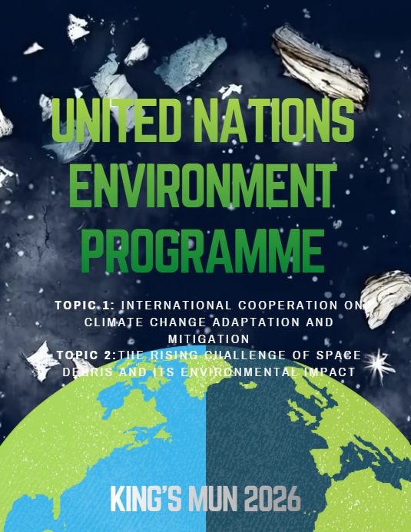
Letter from Secretary Generals

Dear King’sMUN 2026 delegates,

As this year’s Co-Secretary Generals of King’sMUN, we are truly honoured to welcome you to our 12th annual conference. The Secretariat has been working hard throughout this school year to deliver you an incredible, in-person conference with various unique committees, experienced chairs, and a fruitful day of debate.

Model United Nations, a reenactment of the function of the United Nations, is designed for students to come together to debate, discuss, and develop creative resolutions to various pressing issues that plague our current world. In most committees, students take on the positions of multiple countries, characters, or political figures to create solutions for real and fictional issues and crises. Our committees delve into historical events, future scenarios, and fictional topics.

In our personal experiences with MUN, we have developed many skillsets which will lead us throughout our lives, such as confidence in public speaking, leadership, collaboration,
and creative problem-solving. Furthermore, MUN promotes lifelong connections, as we meet delegates who share similar passions in committee sessions. We genuinely believe that your participation in MUN will guide you throughout your high school journey and beyond.

At King’sMUN, we provide a variety of committees to ensure that we have something of interest for everyone. From very current pressing issues (i.e. UNSC and the GA) and issues in sports (i.e. NFL) to fictional committees, yet applicable issues (i.e. Pokémon, Grammys, and Zootopia), issues set in our very own communities (i.e. Ontario Secondary and Post-Secondary Education and Government of Canada) and future-projected crises to promote critical thinking (i.e. Canada vs. U.S. and Artificial Intelligence). We strive to ensure that there is appeal for a variety of delegates, so that you can truly engage with MUN’s benefits in a way that resonates with you. Whether you have no experience or have attended many conferences, there is a place at King’sMUN for you!

Once again, we are thrilled to welcome all delegates, new or returning, to King’sMUN. We hope you will engage in fruitful debate and have a fantastic time at King’sMUN 2026.

Sincerely,
Eva Hanoudi and Ishan Ramchandani
Co-Secretary Generals
King’sMUN 2026

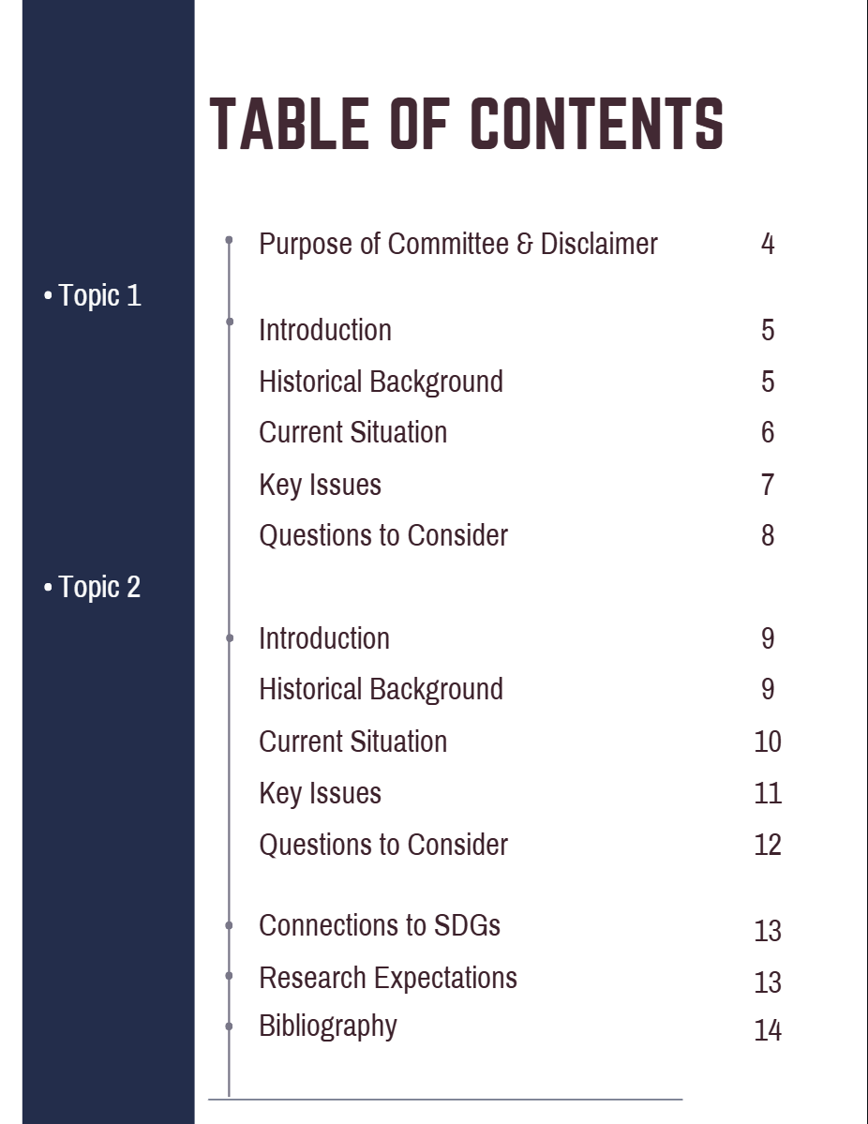

Purpose of Committee, and Disclaimer on Sensitive Topics
The United Nations Environment Programme (UNEP) serves as the leading global authority on environmental issues within the United Nations. This committee is responsible for facilitating international collaboration and developing policies to address urgent environmental challenges that transcend national borders. In this committee, delegates will address two critical and interconnected topics: international cooperation on climate change adaptation and mitigation, and the rising challenge of space debris and its environmental impact.
The purpose of this committee is to encourage constructive debate, balanced perspectives, and innovative solutions that reflect the environmental, economic, technological, and humanitarian dimensions of these issues. Delegates are expected to represent their assigned countries, base their stances on facts and evidence, and work collaboratively to propose realistic and sustainable solutions.
Delegates must bring two printed copies of their position paper. This conference is technology-free, so only physical documents are permitted. Delegates may not use electronic devices during moderated caucuses; however, technology may be used during unmoderated caucuses for the purpose of drafting resolution papers.
The topics discussed in this committee involve sensitive global issues, including environmental degradation, economic inequality, and harmful impacts on vulnerable populations. Delegates should approach debate with respect, professionalism, and cultural sensitivity at all times.
Speeches should avoid inflammatory language, personal attacks, or targeting specific nations, groups, or individuals. While robust debate is encouraged, all discussion must remain diplomatic and aligned with the principles of the United Nations, including cooperation, mutual respect, and peaceful resolution of global challenges.
If you have any questions or concerns before the conference, please don’t hesitate to reach out at gabbyirumhekha@gmail.com.

Topic 1: International cooperation on climate change adaptation and mitigation

Introduction
Climate change refers to a long-term shift in temperatures and weather patterns. A shift can occur naturally due to changes in the sun’s activity, large volcanic eruptions, etc... However, since the 1800s, human activity has been the primary cause of climate change. The burning of fossil fuels such as coal, oil, and gas now accounts for approximately 68% of global greenhouse gas emissions and 90% of all carbon dioxide emissions. Greenhouse gases (such as methane and carbon dioxide) absorb the sun's heat as it radiates from the earth's surface, trapping it in the earth’s atmosphere. As a result, global temperatures are rising, and many nations are grappling with the effects of deadly heat waves, wildfires, and other heat-related health risks. At the same time, warmer air and ocean currents are fueling stronger, more frequent storms that cause flooding, destruction, and major economic losses. Climate change is also reducing the availability of fresh water in many regions. An increasing number of droughts is threatening our agriculture and food security, the biodiversity of our ecosystems, and our access to safe, clean drinking water, putting millions of people at risk. These conditions continue to worsen, having detrimental impacts on communities around the world. Climate change does not respect borders; it is a global crisis of unprecedented scale affecting our physical, social and economic well-being.
Historical Background
The United Nations has been a key leader in global efforts to address climate change, advocating for governments to take faster and stronger action. Recognizing the growing threat, the United Nations adopted the United Nations Framework Convention on Climate Change (UNFCCC) in 1992. The Convention acknowledged that climate change posed a serious threat and committed member states to act in the interest of human safety with the ultimate goal of stabilizing greenhouse gas concentrations at a level that would prevent dangerous anthropogenic (human-induced) interference with the climate system.
Each year, the now 198 Parties to the UNFCCC meet to assess progress, providing the basis for key international climate negotiations such as the Kyoto Protocol (1997) and the Paris Agreement (2015). The Paris Agreement is a landmark, legally binding international treaty adopted at COP21 in Paris, France. Its main goal is to keep global temperature rise well below 2°C above pre-industrial levels and aim to limit it to 1.5°C. World leaders emphasize the 1.5°C target because exceeding it would lead to more severe climate impacts, including harsher droughts, heatwaves, and heavier rainfall.
Furthermore, since its adoption, the Conference of the Parties (COP) has played a vital role in bringing countries together to discuss, negotiate, and take action on climate change. At COP29 in Baku, Azerbaijan (2024), governments agreed to set a New Collective Quantified Goal on climate finance of at least $300 billion per year by 2035, tripling the previously agreed upon target. COP30, the UN climate conference in Belém, Brazil, concluded on November 22nd of this year with an agreement calling for the tripling of funding for developing nations to protect their people from the growing impacts of the climate crisis and to step up support for workers and communities in the transition to clean energy.
These developments highlight the UN’s role in shaping a coordinated global response to climate change by setting shared goals, fostering cooperation, and reducing emissions to support developing countries, protect the environment, and improve lives.
Current Situation
Currently, the planet faces a dire crisis as global temperatures continue to rise and greenhouse gas emissions hit a record high of 57.1 gigatons of CO2 in 2023, a 1.3% increase from 2022. In addition, the World Meteorological Organization (WMO) confirmed 2024 as the hottest year on record, with emissions skyrocketing 2%, approximately 1.55°C above pre-industrial levels. According to the Sustainable Development Goal Report 2025, the Earth is already about 1.2°C warmer than it was in the late 1800s and emissions continue to rise. In the next decade, global temperatures are likely to exceed 1.5 °C above pre-industrial levels, failing to reach the temperature goal the Paris Agreement established to avoid the worst effects of climate change. Despite it being a decade since this agreement, humanity has shown little progress in reducing the burning of fossil fuels, and greenhouse gases are being pumped out at a record rate. As of today, there is more carbon dioxide in the atmosphere than at any point in the last 2 million years.
The Climate Crisis is worse than ever before as increasingly frequent and intense extreme weather events are already impacting every region on Earth, including a surge of heat waves, droughts, floods, tropical storms, and wildfires. The changing weather patterns are leading to food and water insecurity in regions dependent on agriculture, fisheries, and livestock farming, making food production less reliable and driving hunger. Water scarcity is also a critical issue as many people lack access to safe drinking water, which, along with air pollution, diseases, and extreme heat, can pose major health risks and strain healthcare systems. Climate change disproportionally affects the poor and more vulnerable populations, exacerbating existing economic inequalities and pushing more people into poverty.
The pace and scale of current climate action plans is insufficient. The Emissions Gap Report estimates that even if countries live up to their Nationally Determined Contributions (NDCs) to reduce greenhouse gas emissions, the world will warm by 2.3°C to 2.5°C by the end of the century. However, some nations are leading the way in efforts to avert a climate disaster and mitigate the effects of climate change. Denmark, Djibouti, and Lithuania are presently leading the charge on renewable energy (Climate Council). The Climate Change Performance Index (CCPI) ranks countries based on greenhouse gas emissions, renewable energy, energy use, and climate policy and assesses whether they align with the Paris Agreement Goals (Navarre).
Key Issues
Climate Change is wreaking havoc on communities, economies, and ecosystems worldwide, and urgent and transformative action is imperative. Time is of the essence, and immediate measures must be taken to avoid catastrophic consequences and secure a sustainable future. Delegates should focus on tackling the core drivers of climate change, particularly the widespread reliance on fossil fuels such as oil, gas, and coal, which are the largest sources of greenhouse gas emissions. Key issues include reducing our reliance on fossil fuels, expanding renewable energy sources, and managing natural resources more sustainably. Delegates should also examine how emission reductions can be applied across entire economies, including energy, transportation, and industry, while recognizing the different capacities and responsibilities of individual countries.
Another central issue is climate equity and the unequal impacts of climate change. Developing countries often contribute the least to global emissions yet face the most severe consequences, including extreme weather events, food insecurity, and economic instability (Adom). The debate should address financial support, disaster relief, and aid mechanisms for vulnerable nations, as well as setting new, clear, measurable climate goals to achieve net zero emissions and ensuring accountability among all countries.
Questions to consider
- What strategies can countries use to transition away from relying on fossil fuels and expand renewable energy?

- How can global climate agreements better ensure accountability and real progress towards meeting temperature goals such as limiting warming to 1.5°C?

- How should climate finance be structured to support developing countries facing the most severe climate impacts despite contributing the least to emissions?

- What role should international organizations like the United Nations play in coordinating disaster relief, adaptation efforts, and long-term solutions?

- How can climate mitigation and adaptation policies be designed to reduce global inequality while protecting ecosystems, food security, and public health?

- What needs to happen for the world to get back on track to reach its climate goals?

Topic 2: The rising challenge of space debris and its environmental impact

Introduction
Space debris is defined as any non-functional, man-made object in Earth’s orbit that no longer serves a useful purpose. This space junk includes abandoned hardware, mission fragments, and debris from satellite collisions and explosions. It enters low Earth orbit (LEO), creating an orbital space junkyard with millions of pieces of debris. This junkyard is hazardous to Earth’s atmosphere and environment. Large numbers of satellites and debris pose significant collision risks to active spacecraft due to their extreme speeds of up to 28,800 kilometers per hour - almost seven times faster than a bullet! Space debris threatens the sustainability of space-related activities that support our life on Earth such as climate monitoring and communications, making space itself an emerging environmental concern.
With thousands of active satellites and a rapidly increasing number of planned satellite constellations, the risk of collisions rises exponentially. Space debris affects not only major spacefaring nations, but also developing countries that rely on satellite technology for weather forecasting, navigation, and communications. Collisions in orbit can produce thousands of new fragments, creating a chain reaction known as the Kessler Syndrome, which could render key orbits unusable for decades (Holbrook). Beyond technical and economic consequences, space debris represents a shared environmental hazard as its uncontrolled proliferation threatens the long-term sustainability of space exploration and the crucial services it provides to life on Earth.
Historical Background
The issue of space debris was recognized in the late 1970s as a growing threat to the space environment. A key early response was the creation of NASA’s Orbital Debris Program in 1979 at the Johnson Space Center in Houston, Texas. This program marked one of the first coordinated efforts to study space debris, focusing on understanding how debris is created, improving methods for tracking objects in orbit, and developing ways to reduce and remove debris. As satellite launches increased, research from programs like NASA’s highlighted the risks of collisions, which can create cascading debris and further damage Earth’s orbital environment.
At the international level, the United Nations has played a key role in addressing space debris through the United Nations Committee on the Peaceful Uses of Outer Space (COPUOS). The UN developed the Space Debris Mitigation Guidelines, which encourages states to limit the release of debris during missions and safely dispose of spacecraft after their operational life. The UN has also adopted the Long-Term Sustainability (LTS) Guidelines, which promote responsible behaviour in space, international cooperation in debris tracking and research, and the protection of the orbital environment. Although these guidelines are non-binding, many countries are encouraged to apply them through national laws and space policies.
In 2024, world leaders adopted the Pact for the Future, reaffirming their commitment to the safe, peaceful, and sustainable use of outer space. The agreement recognizes that space debris is not only a technical challenge but also an environmental and international security concern. It establishes frameworks for space traffic management, debris mitigation, and the use of space resources, building upon and implementing mechanisms previously developed by COPUOS. Countries such as Germany, the United Arab Emirates, and Peru emphasized their commitment to advancing the outcomes of the UN World Space Forum within COPUOS, urging all nations to actively participate in safeguarding the orbital environment for future generations.
Current Situation
Space technology benefits communities worldwide, enabling navigation, weather forecasting, global communications, and internet access. However, the rapid accumulation of satellites, defunct spacecraft, and debris is creating a dangerous orbital environment. Even tiny debris can cause catastrophic damage, travelling at 28,800 km/h. A single collision releases a similar quantity of energy to a hand grenade, destroying active satellites and spacecraft, and creating more debris, which increases the likelihood of future collisions.
As of 2025, there are roughly 11,000 active satellites and more than 40,000 tracked objects in orbit, with millions of smaller debris fragments. It is expected that this number could increase to hundreds of thousands by the end of this decade as private companies like Elon Musk’s Starlink and Amazon’s Kuiper join China, the U.S., Russia, and Europe in building mega-constellations in LEO. Mega-constellations are massive networks of interconnected satellites, offering substantial benefits like improved internet access, but also escalating the risk of in-space collisions and long-term sustainability challenges. The drive to populate LEO with thousands of satellites within mega-constellations could lead to an unsustainable increase in space debris, close encounters due to orbital congestion, light pollution and potential monopolization of critical orbital paths.
Additionally, approximately 80 tons of space debris re-enter Earth’s atmosphere each year. While most debris disintegrates, the breakdown process releases chemicals that deplete ozone and contribute to atmospheric pollution. The debris that survives re-entry causes potential hazards to the ground. Despite these dangers, there are no binding international laws requiring debris removal or orbital traffic coordination. Current efforts rely on national regulations and guidelines like the US FCC's 5-Year Rule, ESA's Zero Debris approach, and the UN’s COPUOS Guidelines, which focus on mitigation and push towards future remediation laws. However, experts warn that without enforceable rules, active debris removal, and stricter launch standards, the very space infrastructure modern life depends on could be at risk.
Key Issues
Space junk is no one country’s responsibility. While major spacefaring nations generate most of the debris, the consequences affect all countries that depend on satellite services to support climate monitoring, navigation, communications, disaster response, and internet access. Addressing this issue is a shared obligation, both as an international challenge and an opportunity to preserve the space environment for future space exploration missions.
Delegates should prioritize the issue of space debris polluting Earth’s upper atmosphere with harmful materials during satellite reentry, as well as the growing number of satellites, defunct spacecraft, and collision fragments currently present in low Earth orbit. The rapid deployment of large satellite networks raises significant concerns, as it increases the risk of close encounters, contributes to light pollution, and creates the potential for monopolization of critical orbital pathways. It is imperative to consider the need for new global responses that include enforceable international laws for debris removal, space traffic management, and launch limits. Effectively managing space debris requires coordinated global action, stronger space governance, and collective investment in mitigation and debris-removal technologies.
Questions to Consider
- How can existing international guidelines be strengthened and implemented to establish global rules for space debris mitigation, removal, and space traffic management?
- What responsibilities should spacefaring nations and private companies hold in preventing and reducing the creation of space debris?
- How can countries effectively mitigate the environmental impacts of space debris, including atmospheric pollution, ozone depletion, and light pollution?
- What measures are necessary to ensure that outer space remains a shared global resource rather than being dominated or monopolized by a few nations?
- How can countries work together to make satellite design, launches, and disposal more environmentally sustainable, protecting both space and Earth’s atmosphere?

Connections to the UN Sustainable Development Goals (SDGs)
Goal 13: Climate action- Take urgent measures to combat climate change and its impacts
Discussing international cooperation on climate change adaptation and mitigation directly addresses this goal as countries work together to develop strategies, share technology, and support vulnerable regions. By collaborating on both adaptation and mitigation efforts, nations can reduce greenhouse gas emissions and ensure a more sustainable future. (United Nations, “Goal 13: Take Urgent Action to Combat Climate Change and Its Impacts”)
Furthermore, debating the rising challenge of space debris and its environmental impact is highly relevant as satellites play a key role in monitoring climate patterns, forecasting weather, and aiding in disaster management; all of this could be disrupted by space debris (“The Race to Save Space”).
Research expectations
Delegates are expected to come prepared with a strong understanding of their country’s environmental policies, priorities, and constraints. When addressing climate change, delegates should focus on mitigation strategies, adaptation efforts, climate equity, resource management, and international cooperation. When discussing space debris, delegates should consider environmental sustainability, shared responsibility in outer space, risk mitigation, and long-term impacts on Earth and space-based systems.
To begin your research, use reliable sources including official government websites, UN publications, and reports from recognized environmental organizations such as the UN Environment Programme (https://www.unep.org/), the Intergovernmental Panel on Climate Change (https://www.ipcc.ch/sr15/), and the United Nations Office for Outer Space Affairs (https://www.un.org/en/content/feature/theracetosavespace/#header).
When researching, compare your country’s policies with working global practices to identify realistic and innovative solutions. Take notes on key statistics and past resolutions that support your arguments. All proposals should be realistic, evidence-based, and consistent with your country's policies, international law and existing UN frameworks.

Works Cited

Adom, Philip Kofi. “The Socioeconomic Impact of Climate Change in Developing Countries over the next Decades: A Literature Survey.” Heliyon, vol. 10, no. 15, 1 Aug. 2024, pp. e35134–e35134, https://doi.org/10.1016/j.heliyon.2024.e35134

Climate Council. “11 Countries Leading the Charge on Renewable Energy.” Climate Council, Climate Council, 15 Aug. 2022, www.climatecouncil.org.au/11-countries-leading-the-charge-on-renewable-energy/

“Emissions Gap Report.” www.unep.org, UNEP, 2025, www.unep.org/resources/emissions-gap-report

Holbrook, Emily. “Risk Management Magazine - Time Line: Space Waste.” Magazine, 1 Oct. 2011, www.rmmagazine.com/articles/article/2011/10/01/-Time-Line-Space-Waste-
Accessed 31 Dec. 2025.

Jankowitsch, Peter. “Committee on the Peaceful Uses of Outer Space.” Space Policy, vol. 1, no. 1, Feb. 1985, pp. 90–95, https://doi.org/10.1016/0265-9646(85)90050-5.
Accessed 22 Dec. 2025.

“Managing Mega-Constellations.” www.esa.int, 5 2017, www.esa.int/Enabling_Support/Preparing_for_the_Future/Discovery_and_Preparation/Managing_mega-constellations

NASA. “Space Debris.” NASA, NASA, 3 Nov. 2023, www.nasa.gov/headquarters/library/find/bibliographies/space-debris/

Nations, United. “— SDG Indicators.” Un.org, 2025, unstats.un.org/sdgs/report/2025/?_gl=1

Navarre, Brianna. “The 10 Countries Leading the Way on Climate Change.” US News & World Report, U.S. News & World Report, 2024, www.usnews.com/news/best-countries/slideshows/countries-leading-the-way-on-climate-change

Pearce, Warren, et al. “Climate Change on Twitter: Topics, Communities and Conversations about the 2013 IPCC Working Group 1 Report.” PLoS ONE, vol. 9, no. 4, 9 Apr. 2014, p. e94785, https://doi.org/10.1371/journal.pone.0094785

Suri, Rajeev. “Environmental Impact of Space Debris and How to Solve It.” World Economic Forum, 13 July 2022, www.weforum.org/stories/2022/07/environmental-impact-space-debris-how-to-solve-it/

“The Environmental Impact of Space Debris.” Environment + Energy Leader, www.environmentenergyleader.com/stories/the-environmental-impact-of-space-debris,1177

“The Race to Save Space.” Un.org, United Nations, 2025, www.un.org/en/content/feature/theracetosavespace/#section-3 Accessed 28 Dec. 2025.

UNEP. “About the United Nations Environment Programme.” UNEP - UN Environment Programme, 2024, www.unep.org/who-we-are/about-us.

UNEP. “The World Is Likely to Exceed a Key Global Warming Target Soon. Now What?” UNEP, 2025, www.unep.org/news-and-stories/story/world-likely-exceed-key-global-warming-target-soon-now-what

UNFCCC. “The Paris Agreement.” United Nations Climate Change, 2025, unfccc.int/process-and-meetings/the-paris-agreement

---. “United Nations Framework Convention on Climate Change | UNFCCC.” Unfccc.int, 2020, unfccc.int/process-and-meetings/united-nations-framework-convention-on-climate-change Accessed 8 Sept. 2025.

United Nations. “Causes and Effects of Climate Change.” United Nations, 2022, www.un.org/en/climatechange/science/causes-effects-climate-change

---. “Goal 13: Take Urgent Action to Combat Climate Change and Its Impacts.” Sustainable Development Goals, United Nations, 2025, www.un.org/sustainabledevelopment/climate-change/

---. “UN Climate Change Conferences.” United Nations, 2024, www.un.org/en/climatechange/un-climate-conferences

---. “What Is Climate Change?” United Nations, 2025, www.un.org/en/climatechange/what-is-climate-change

“UNOOSA and ESA Release Infographics and Podcasts about Space Debris.” www.unoosa.org, United Nations Office for Outer Space Affairs, www.unoosa.org/oosa/en/informationfor/media/unoosa-and-esa-release-infographics-and-podcasts-about-space-debris.html

“What Is Space Debris?” www.esa.int, www.esa.int/Space_Safety/Clean_Space/What_is_space_debris

United Nations, “What Is Climate Change?”
United Nations, “Causes and Effects of Climate Change”
UNEP, “About the United Nations Environment Programme”
UNFCCC, “United Nations Framework Convention on Climate Change | UNFCCC”
United Nations, “UN Climate Change Conferences”
UNEP, “Emissions Gap Report”
UNEP, “The World Is Likely to Exceed a Key Global Warming Target Soon. Now What?”
United Nations, “Five Ways the Climate Crisis Impacts Human Security”
UNEP, “The World Is Likely to Exceed a Key Global Warming Target Soon. Now What?”
“What Is Space Debris?”
NASA, “Space debris”
United Nations, “Committee on the Peaceful Uses of Outer Space”
“UNOOSA and ESA Release Infographics and Podcasts about Space Debris”
NASA, “Space debris”
United Nations, “Pact for the Future - United Nations Summit of the Future | United Nations”
“The Race to Save Space”
European Space Agency
UNFCCC, “The Paris Agreement”
“Managing Mega-Constellations”
“The Environmental Impact of Space Debris”

